Name: Ruiz, Arnie A. Date: 05-04-26

Course/Year/Section: BSIT-3B

Individual Activity4: “Design Your Own System Using UML”
Title: Library Book Borrowing System

Part 1
UML list
Use Case Diagram – Shows how users (actors) interact with the system and the actions they can perform. It focuses on user goals and system functions.
Activity Diagram – Illustrates the step-by-step flow of activities in a system process. It shows decisions, actions, and the overall workflow.
Class Diagram – Displays the structure of the system by showing classes, their attributes, methods, and relationships. It helps define how data is organized.
Sequence Diagram – Shows how objects interact in a specific order over time. It focuses on the sequence of messages exchanged between components.

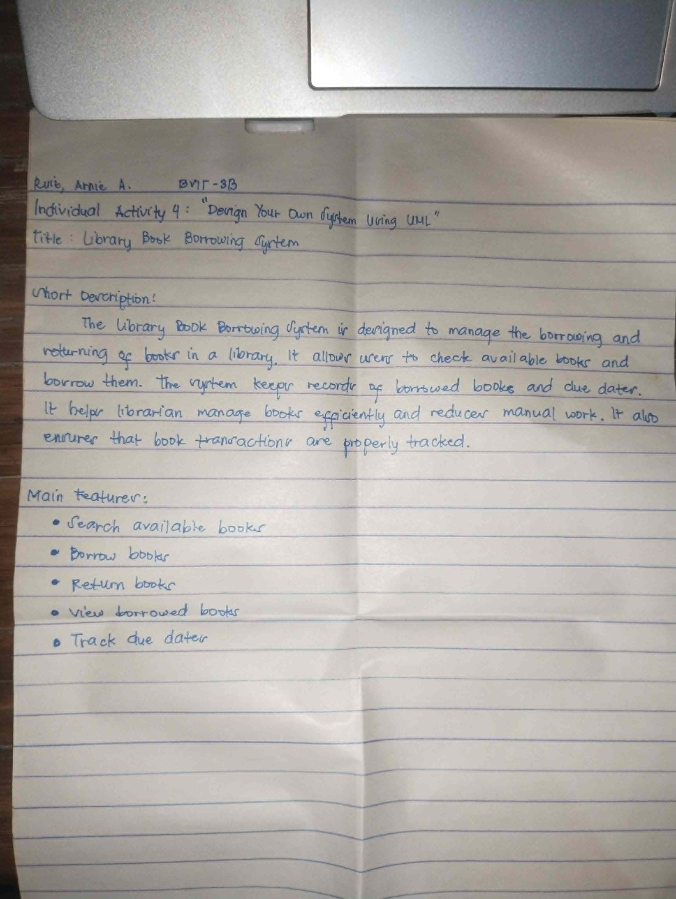

Part 2
UML Diagram Creation
1. Use Case Diagram:

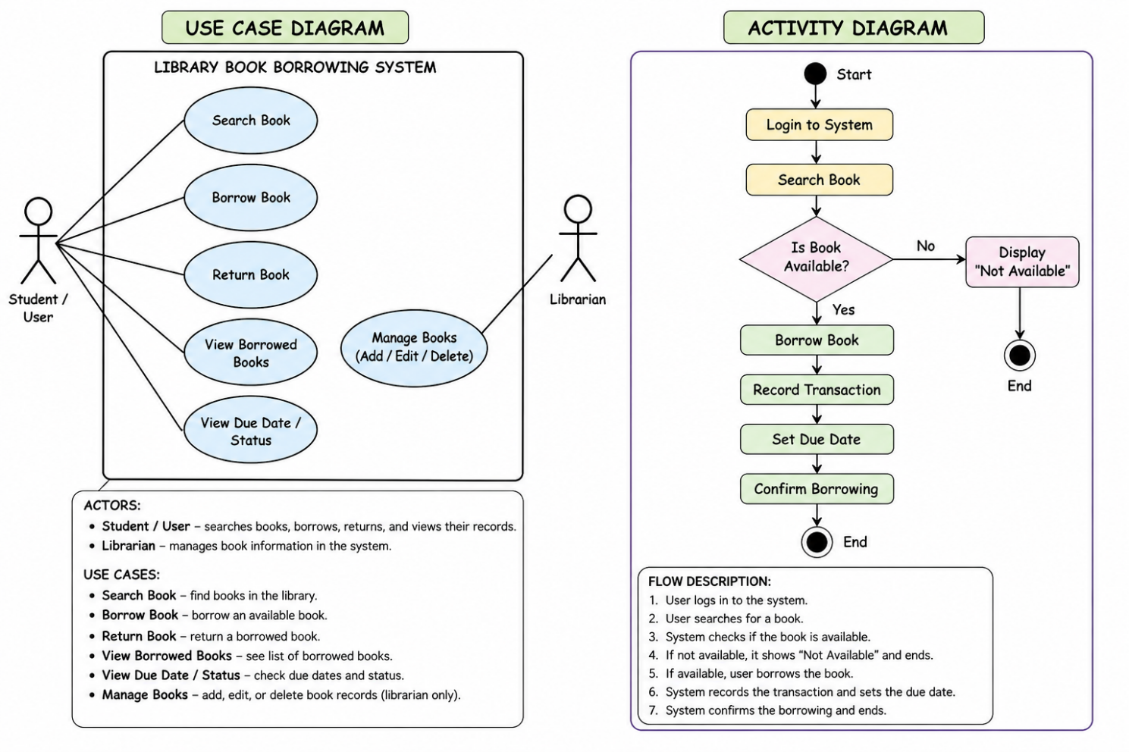

2. Activity Diagram:

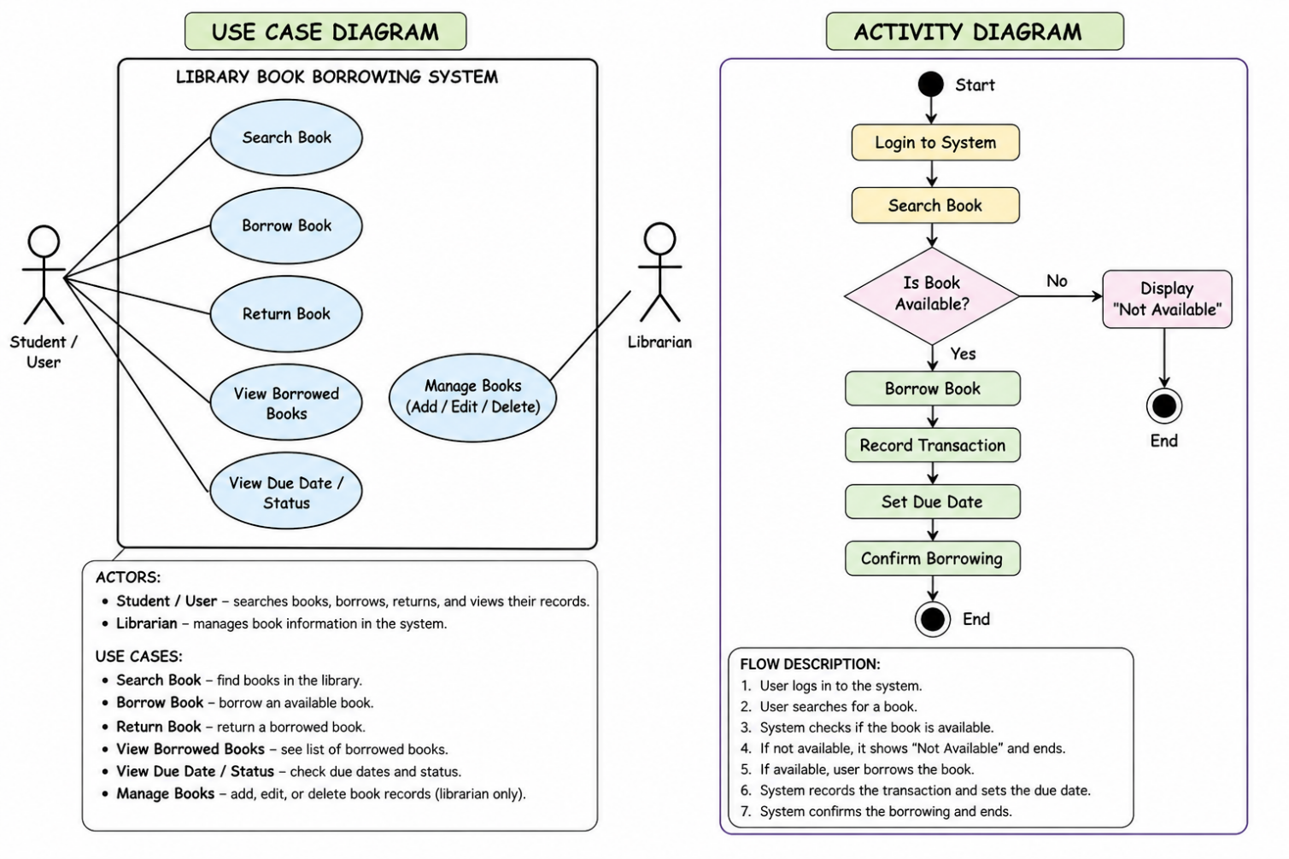

Part 3
SDLC Application

Planning
Identify the need for a system to manage book borrowing. It helps reduce manual work in the library.
Design
Create UML diagrams to show how the system will work. It helps us understand the flow and user actions.
Implementation
Build the system using a programming language. We add features like searching, borrowing, and returning books.
Testing
Check if the system works properly. We make sure books can be borrowed and returned correctly and records are accurate.

Part 4
Reflection

1. What did you learn from creating UML diagrams?
I learned that UML diagrams help me plan the system clearly before making it. It shows how the parts connect and make it easier to understand the process.

2. Why is planning (SDLC) important before building a system?
Planning is important because it guides the whole project step by step. It helps avoid problems and makes sure the system is built correctly.

